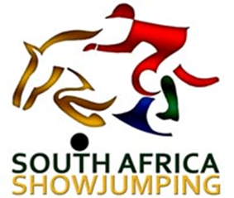

SA SHOW JUMPING PROTEA COLOURS and NATIONAL DRESS CODE POLICY
Approved by: South African Equestrian Federation (SAEF) - Date:

1. PURPOSE & SCOPE
This policy governs the criteria for awarding Protea Colours/National Colours to Show Jumping athletes under the authority of SA Show Jumping (SASJ), in alignment with the SASCOC National Colours Policy, the South African Equestrian Federation (SAEF Colours Policy) National Team Selection Policy, and the SA Show Jumping Regulations.
It ensures alignment with SASCOC, SAEF, FEI and SASJ standards, and promotes fairness, transparency, and excellence in athlete recognition at events where S A Show Jumping Athletes are represented internationally.

2. OBEJCTIVES
-To determine the Rules, Regulations and criteria pertaining to the selection of athletes for National Show Jumping Teams.
- To prevent any misuse or abuse of National Colours.
- To ensure the prestige of National Colours and adhere to the South African Equestrian Federation and SASCOC regulations.

3. DEFINITIONS
- National Colours: Recognition awarded to Athletes officially selected to represent South Africa in Show Jumping.
- Protea Colours (National Colours): Recognition awarded to Athletes officially selected to represent South Africa in Show Jumping - awarded under the SAEF/SASCOC protocols for multi-sport events.
- SAEF Colours: Colours awarded under the SAEF Colours policy.
- Selection Committee: Appointed committee responsible for Athlete Selection within Show Jumping.
- Athlete: Selected Athlete
- Coach: Appointed Coach
- Team Manager: Appointed Team Manager/Chef dÉquipe.

4. ELIGIBILITY REQUIREMENTS
To be eligible for National Colours in Show Jumping, Athletes, Coaches and Team Managers must:
- Be a South African Citizen with a valid South African passport.
- Be a registered member in good standing with SASJ and SAEF.
- Must not be under investigation and/or disciplinary action with any of the governing bodies.
- The Athlete must not be under investigation or serving a period of ineligibility for a breach of any anti-doping or equine anti-doping.
- Be selected through a documented and transparent process, signed off by SASJ, and nominated to SAEF.
- Be the best of the best Athletes for the event.

5. SELECTION PROCESS
- Selection is based on performance, consistency, and commitment.
- The process must be documented, including minutes and signed selection forms.
- Qualification after events with an official FEI invitation for Series events.
- Athletes must receive written notification and complete the SAEF and/or SASCOC Athletes agreements.
- SASJ Executive to ratify and selection and colours application before submission.

6. PROTEA COLOURS

6.1 SENIOR PROTEA COLOURS
6.2 JUNIOR PROTEA COLOURS

7. QUALIFYING EVENTS FOR PROTEA NATIONAL COLOURS

  - Events Qualifying for Protea National Colours
Athletes who through a selection process represent South Africa at an event where other nations have undergone a similar selection process. Selection Criteria to be in place.
Pony Rider, Junior, Young Rider and U25 athletes must meet all eligibility criteria, with performance standards relative to their FEI-defined categories.

- FEI World Jumping Championships = Senior Protea Colours.
Athletes who are selected as the RSA Show Jumping Team or the 2 RSA Individual to compete at the FEI World Jumping Championships. Selection Criteria to be in place.

- FEI Jumping World Cup Final = Senior Protea Colours.
Athlete who wins the FEI South African Jumping World Cup League, qualify and receive and invitation from the FEI to compete in the FEI Jumping World Cup Final and partake either on their own horse or another horse.

- FEI CSIO Nations Cups (Senior) = Senior Protea Colours.
Athletes who are selected as the RSA Show Jumping Team for the relevant event. Selection Criteria to be in place.

- FEI CSIO J/YR/U25 = Junior Protea Colours.
Athletes who are selected as the RSA Show Jumping Team for the relevant event, in the relevant age category. Selection Criteria to be in place.

- Senior Tri Nations & Senior Nations Cups = Senior Colours
Athletes who are selected as the RSA Show Jumping Team for the relevant event. Selection Criteria to be in place.

- U25/YR/Junior Tri Nations & Nations Cups = Junior Protea Colours
Athletes who are selected as the RSA Show Jumping Team for the relevant event. Selection Criteria to be in place.

- FEI Youth Equestrian Games = Junior Protea Colours.
Athlete/s who are selected as the RSA Athlete for the relevant event. Selection Criteria to be in place.

- FEI CSIO Children or Pony Rider = Junior Protea Colours.
Athletes who are selected as the RSA Show Jumping Team for the relevant event, in the relevant age category. Selection Criteria to be in place.

- Other National Team Events
A Team who through a selection process represents South Africa at an event of SASJ National status where other nations have undergone a similar selection process. There should be a minimum of Two Nations competing.

  - Series Finals Qualifying for Protea National Colours

- FEI Jumping Children’s Classics Final = Junior Protea Colours
Athletes 14 years and under who have competed (Pony or Horse) and qualified by invitation from the FEI to compete in the FEI Children’s Classics Final and compete in the final on borrowed horses.
- FEI Jumping World Challenge Final – Colour Allocation Policy
Junior Athletes
Athletes who have competed in the relevant qualifying events and met the FEI standards to receive an invitation to the FEI Jumping World Challenge Final, and who subsequently compete in the Final on borrowed horses, shall be automatically awarded Junior Protea Colours. This recognition reflects the international nature of the event and the athlete’s achievement in representing South Africa at FEI level.
Adult Athletes
As the FEI Jumping World Challenge Final is not considered the highest level of international competition for adult athletes, those who qualify and compete in the Final shall be eligible to apply for SAEF Colours, subject to SAEF’s standard application and approval process.

Athletes who have competed in the relevant events and met the qualifying standards to achieve results to qualify and receive an invitation from FEI to compete in the FEI Jumping World Challenge Final and compete in the final on borrowed horses. (automatically selected)

  - Events Qualifying for SASCOC Official Colours.
- Olympic Games = SASCOC Olympic Colours
- Youth Olympic Games = SASCOC Youth Olympic Colours
- All Africa Games = SASCOC All Africa Games Colours
Athletes who are selected as the RSA Show Jumping Team or RSA Individual Athlete for any of the above events. Selection Criteria to be in place.
Athletes who received these SASCOC Colours may compete in SASJ Events with an RSA Flag on their jackets and other apparel.

8. ENDORESEMENT PROCESS AND ISSUANCE OF NATIONAL COLOURS
- After the selection has been ratified by SASJ Executive the nomination process will be submitted to SAEF for approval and submission to SASCOC.
- SASCOC Protea Colours may only be awarded by SASCOC.
- SASJ Will submit the application to SAEF for Submission to SASCOC.
- Only upon receipt of the Official colours letter will Athletes, Team Manager and Coaches be allowed to wear the Official National Colours.

9. QUALIFYING EVENTS FOR SAEF COLOURS.
- FEI Group IX Inter Africa = SAEF Silver Colours
- Other FEI Group IX/ACES Events not on the FEI Calendar = As per 2025 SAEF Colours policy.

10. REVOCATION AND APPEALS
- Colours may be revoked for misconduct or regulatory breaches.
- Appeals can be lodged through the SAEF Appeals Committee.

11. CODE OF CONDUCT
- All Athletes, Team Managers and Coaches must uphold professionalism, ethics, and integrity at all times.
- Senior Athletes are expected to uphold mentorship roles and set examples for younger athletes.

12. AMENDMENTS AND REVIEW
This policy is reviewed periodically by SASJ in consultation with SAEF and SASCOC.

13. KIT AND BRANDING GUIDELINES
- All kits must be approved by SAEF and SASJ prior to production and use at the event.
- The use of National Symbols (e.g., SASCOC logo, Protea, RSA Flag on in competition kit) is restricted to authorized athletes, coaches, and Team Managers.
- Sponsor Logos must comply with SASCOC, FEI, SAEF and SASJ branding regulations.
- Unauthorized use of national emblems may result in disciplinary action.

Prepared by
SA Show Jumping National Executive Committee

APPENDIX A

PROTEA TEAMS AND ATHLETES
- THE FOLLOWING EMROIDERY AS ALLOWED ON PROTEA BLAZERS
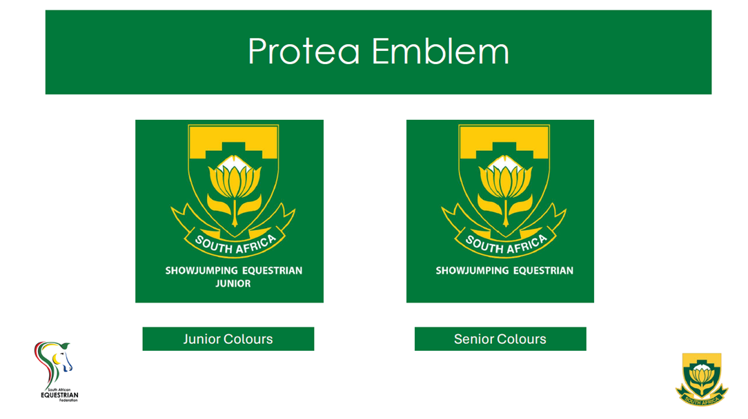
Team Manager and Team Coach to be under the relevant badge.

- PROTEA STEP OUT KIT

LADIES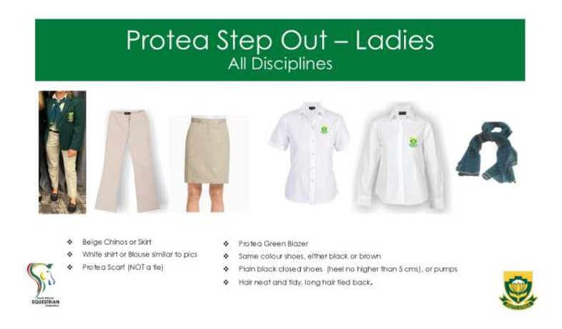
- Beige Chinos or Skirt (Skirt not more than 12cm above the knee)
- White Shirt or Blouse
- Protea Scarf (Not tie)
- Protea Green Blazer
- Plain Black or Brown (Team all be the same) closed shoes (Heel not higher than 5 cm)
- NO Taakies
- Hair neat and tidy, long hair tied back.

MEN
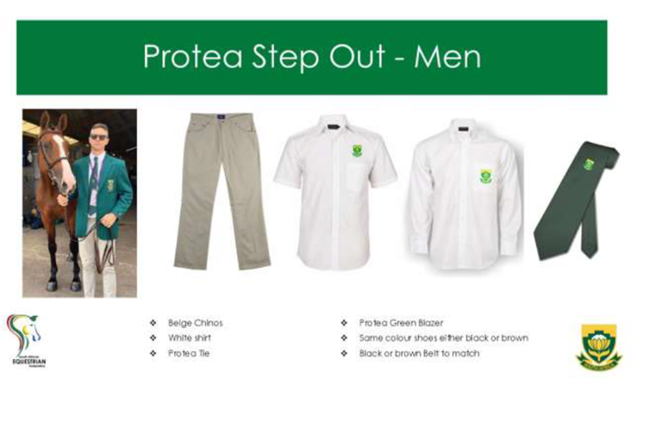
- Beige Chinos
- White Shirt
- Protea Tie
- Protea Green Blazer
- Plain Black or Brown Closed Shoes (Team all be the same) No Taakies.
- COMPETITION KIT

White Breeches and Black Boots
RIDING JACKETS
The South African national flag may only be displayed on competition jackets that are Green, Navy, Red, or Black in colour.
Riding Jackets in any other colour shall not bear the national flag, unless explicitly authorized by the SASJ Executive Committee for ceremonial or international representation purposes
(Flag size on the left breast and/or sleeve) = The maximum allowable size is:
Height: 3 cm
Width: 5 cm

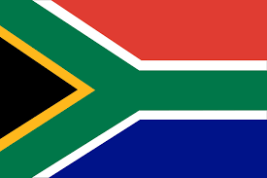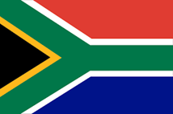
JUNIOR
Only RSA Athletes that have received Official SASCOC Protea or other colours may compete with a South African Flag in the arena on their jackets – in South Africa and Abroad and compete in Green Riding Jackets.
- Green Jacket Junior Protea Colours – Plain Green
- Green Jacket Junior Protea Colours (YR & U25 Athletes – Green with Gold piping on Collar
- Green Jacket Senior Protea Colours – Green with Black Collar and Gold piping
Riding outside of South Africa with a South African flag is allowed only in competitions where the athlete has been entered in an FEI competition by SAEF as a South African entry or in any official team competitions. (Refer to SAEF Colours Policy)
Athletes competing outside of South Africa may have the RSA Flag on their non competition wear outside the field of play.
Athletes with Senior Protea colours may also have an RSA flag on their competition shirts on the collar.
SADDLECLOTHS
White Saddlecloths with an RSA Flag may only be used in Team Competitions in South Africa where the Athlete is part of an official South African Team, authorised by SASJ.
Coloured South African Saddlecloths may be used for training and warm up competitions.
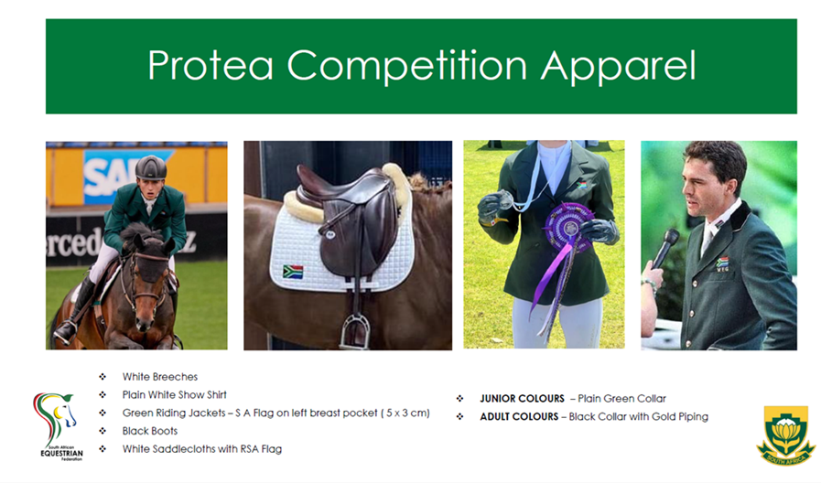
EAR VEILS
Ear Veils with SA Flag or authorised SASCOC logo to be green or with permission the the same colour as the horse.
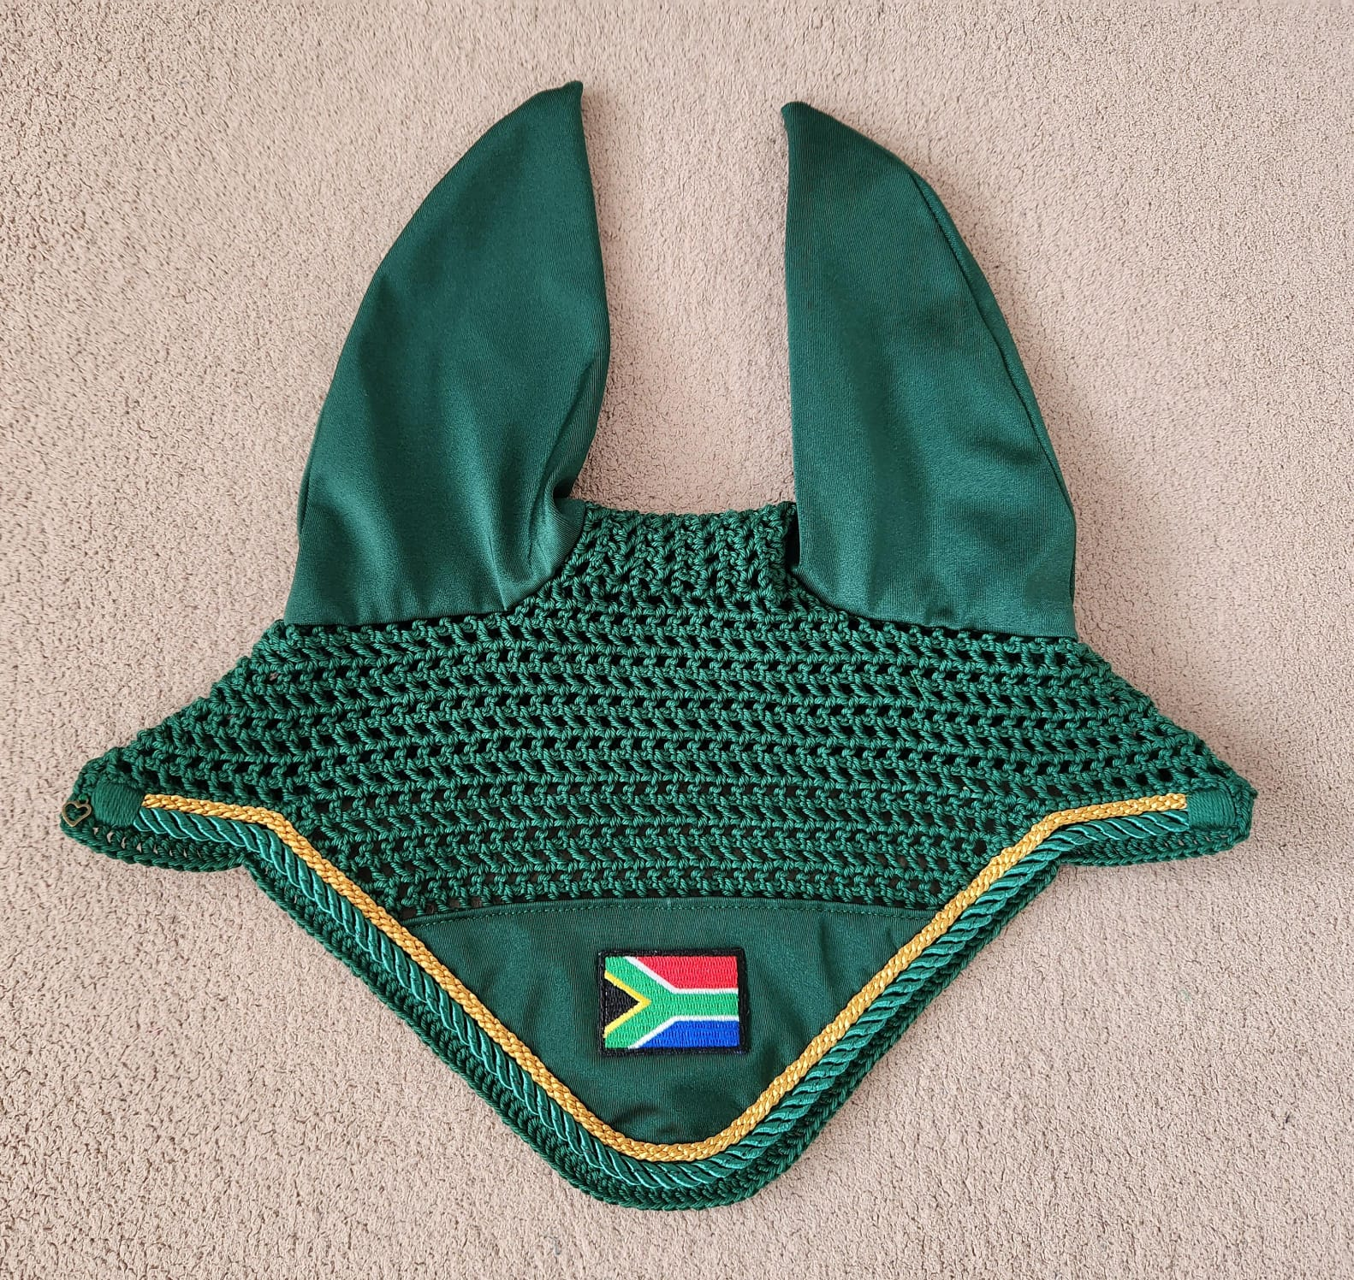

- SASJ STEP OUT KIT (SASJ Official Teams)
For Athletes/Team with non-protea colours

Team Step Outs
- Beige Chinos or Skirt (Skirt not more than 12cm above the knee)
- White Shirt or Blouse
- Protea Scarf (Not tie)
- Protea Green /Navy Blazer
- Plain Black or Brown (Team all be the same) closed shoes (Heel not higher than 5 cm)
- NO Taakies
- Hair neat and tidy, long hair tied back.
Team Competition Kit

- White Breeches
- Black Boots
- Navy/Black Riding Jackets (can have Green Collar)
- White Shirt
- White Saddlecloths with RSA Flag

